11/25/2025
Rakesh s p
[company name]
MSK NOTES
COMPILATION

Location of involved joints
DIP joint involvement is - common in
- psoriatic arthritis,
- osteoarthritis, and
- erosive osteoarthritis
it is not present in rheumatoid arthritis (RA), unless extremely late in the disease.
disease involving the SI joints would raise the possibility of
- ankylosing spondylitis (AS),
- IBD arthritis,
- psoriatic spondyloarthropathy,
- chronic reactive arthritis,
- osteoarthritis, and
- diffuse idiopathic skeletal hyperostosis (DISH).

The protocols vary depending upon whether the clinical question is
- injury, pain or other nonspecific symptoms (ortho protocol),
- infection or inflammation (infection protocol),
- tumor (mass protocol),
- labrum,
- full-thickness rotator cuff tear or
- loose body (MR arthrogram),
- slow-flow or high-flow vascular malformation (vascular malformation protocol),
- cartilage evaluation (cartilage protocol),
- myositis or myopathy (myositis protocol),
- metal prosthesis related complications (metal protocol), and
- peripheral nerve evaluation (MR neurography).
The use of gadolinium-based contrast agents is essential in
- MR arthrograms,
- as well as in cases of suspected infection,
- inflammation,
- vascular malformation, and
- mass lesion.
Image manipulation (postprocessing) becomes important whenever high-end imaging is performed (e.g., with 3D imaging, functional cartilage imaging, and neurography

The dynamic upright studies dramatically demonstrate a hidden disc herniation, which was not revealed on the recumbent scans.

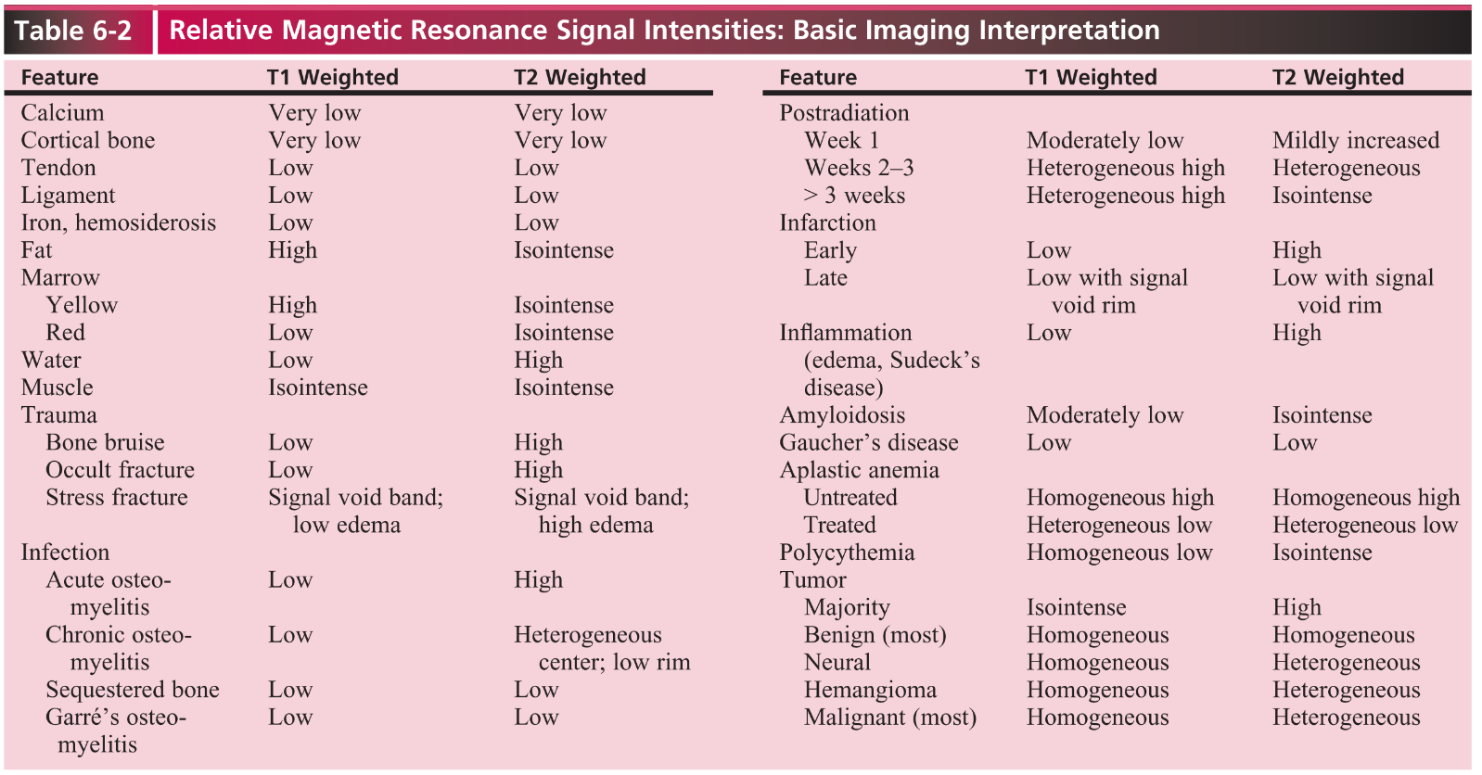

Anatomical region | Key findings to document | Typical descriptors or metrics
Intervertebral discs | Disc degeneration, bulge, protrusion, extrusion, height loss, degeneration pattern | Level-by-level disc morphology and degree of degeneration [1] [2]
Central spinal canal | Central stenosis severity and effect on CSF/cauda equina | Compromise of central zone and relation of fluid to cauda equina (core item) [4]
Lateral recess | Lateral recess narrowing and nerve root compression | Presence/absence and degree of nerve root compression [4] [2]
Foraminal zone | Foraminal stenosis and nerve root impingement | Foraminal zone compromise and nerve root impingement grading [4] [2]
Facet joints | Facet degeneration, hypertrophy, and cysts | Facet arthropathy severity and contribution to stenosis [1] [2]
Ligamentum flavum and ligaments | Hypertrophy, buckling, ossification | Thickness/ossification and role in canal compromise [1] [2]
Spinal cord and conus | Cord signal change, myelomalacia, syrinx, tethering | Cord signal abnormality, level, extent, and associated findings [1] [5]
Bone and marrow | Fractures, marrow edema, spondylolisthesis, osteophytes | Acute vs chronic fractures, instability metrics, bone lesion characterization [1] [2]
Epidural and paraspinal soft tissues | Epidural lipomatosis, abscess, neoplasm, postoperative scarring | Presence, extent, and mass effect on neural structures [1] [3]
Congenital anomalies | Dysraphism elements, tethered cord, fatty filum, diastematomyelia | Detailed checklist items for dysraphic anatomy and associated anomalies [5]

Excellent — this is a comprehensive radiology learning goal. Let’s build your complete structured study and reporting guide for Spine MRI covering:
- ✅ Stepwise Reporting Workflow (Cervical → Thoracic → Lumbar → Sacrum)
- ✅ Systematic Notes (Anatomy, Sequences, Key Pathologies)
- ✅ All Major Classifications and Grading Systems
- ✅ Final Summary Checklist for Routine Reporting

🧠 SPINE MRI REPORTING — COMPLETE STRUCTURED NOTES

I. 🎯 General Reporting Approach
1. Identify Patient & Study Details
- Name, Age, Gender
- Clinical indication (e.g., low back pain, radiculopathy, trauma, infection)
- Technique: Mention MRI sequences and planes (e.g., sagittal T1, T2, STIR; axial T2; contrast if given)

2. Stepwise Evaluation Framework (C → T → L → S)
Step | Level | Evaluate
1 | Alignment | Curvature (lordosis, kyphosis, scoliosis), listhesis
2 | Vertebral Bodies | Height, marrow signal, fractures, edema, hemangiomas, metastases
3 | Intervertebral Discs | Signal intensity, height loss, bulge, herniation, annular tear
4 | Endplates | Modic changes (Type I-III)
5 | Facet Joints & Ligaments | Arthropathy, fluid, ligamentum flavum hypertrophy
6 | Canal & Foraminal Dimensions | Stenosis, compression, perineural cysts
7 | Spinal Cord / Cauda Equina | Morphology, signal, compression
8 | Paraspinal Soft Tissues | Muscle edema, abscess, postoperative changes

II. 🔬 MRI SEQUENCES & KEY SIGNAL PATTERNS
Sequence | Best for | Key Findings
T1 | Anatomy, marrow fat, hemorrhage | Fat bright, marrow replacement dark
T2 | Fluid-sensitive | Disc hydration, edema bright
STIR | Edema & inflammation | Suppresses fat, highlights pathology
T1+C (Contrast) | Infection, tumor, post-op | Enhancement of granulation, tumor margins

III. 🧩 CERVICAL SPINE
Stepwise Evaluation
- Alignment (lordosis reversal, subluxation)
- Cord: signal (myelomalacia, demyelination)
- Discs: bulge/herniation (C5-C6, C6-C7 common)
- Foraminal & canal stenosis
- Facet degeneration
Classifications / Grading
- Kang MRI grading (Cervical canal stenosis)
Grade 0: No CSF obliteration
Grade 1: Partial CSF obliteration
Grade 2: CSF obliteration, cord deformity
Grade 3: Cord signal change
- Matsumoto et al. – Disc Degeneration Scale
Grades 0–4 (from normal → decreased signal + height loss + osteophytes)

IV. 🌄 THORACIC SPINE
- Focus: Alignment, cord signal (syrinx, demyelination, compression fractures, metastasis)
- Evaluate for Schmorl’s nodes, Scheuermann’s disease, or osteoporotic collapse
No universal grading, use descriptive terms (mild/moderate/severe canal narrowing).

V. 🏋️‍♂️ LUMBAR SPINE
1. Alignment
- Lordosis, anterolisthesis/retrolisthesis (use Meyerding grading)
Grade | % Slip
I | <25%
II | 25–50%
III | 50–75%
IV | 75–100%

2. Discs
🔹 Pfirrmann Grading (Disc Degeneration on MRI)
Grade | Signal | Nucleus–Annulus | Height
I | Bright T2 | Clear distinction | Normal
II | Slightly less bright | Clear | Normal
III | Intermediate | Unclear | Normal–slightly reduced
IV | Dark | Lost distinction | Moderately decreased
V | Dark | Lost distinction | Collapsed

🔹 Disc Pathology Terms (per NASS / Fardon & Milette)
- Bulge: >25% of disc circumference extends beyond vertebral margin
- Herniation: <25% of circumference; subdivided into:
  - Protrusion: Base > apex
  - Extrusion: Apex > base
  - Sequestration: Free fragment detached

3. Endplates
🔹 Modic Changes (Vertebral Endplate / Marrow)
Type | T1 | T2 | Meaning
I | Low | High | Edema/inflammation
II | High | Iso–high | Fatty change
III | Low | Low | Sclerosis

4. Canal / Foraminal Stenosis
🔹 Schizas Grading (Lumbar Central Canal Stenosis)
Grade | Description
A | CSF visible
B | Rootlets occupy <50% of canal
C | Rootlets occupy >50%
D | No CSF visible
🔹 Lee Grading (Foraminal Stenosis)
Grade | Perineural fat obliteration
0 | Normal
1 | Partial
2 | Near-complete
3 | Complete with nerve compression

5. Facet Arthropathy
- Hypertrophy, effusion, cyst formation
- Graded mild / moderate / severe based on joint space narrowing and hypertrophy.

6. Ligamentum Flavum Hypertrophy
- Normal ≤4 mm (lumbar); >5 mm suggests hypertrophy.

7. Spinal Canal Dimensions
- Sagittal diameter (normal ≥12 mm; <10 mm = stenosis)

8. Cauda Equina & Nerve Roots
- Evaluate compression, clumping (arachnoiditis), perineural cysts.

VI. ⚙️ TRAUMA CLASSIFICATIONS
System | Region | Key Points
AO Spine | Cervical, Thoracic, Lumbar | Type A (compression), B (tension band), C (translation/rotation)
TLICS (Thoracolumbar Injury Classification & Severity Score) | Thoracolumbar | Morphology (A/B/C), PLC integrity, neuro status
Denis 3-Column Concept | Thoracolumbar | Anterior / Middle / Posterior columns

VII. 🧫 INFECTION
- Evaluate: Discitis, osteomyelitis, epidural abscess
- Key features: Endplate erosion, low T1/high T2, post-contrast enhancement, paraspinal edema

VIII. 🎯 POSTOPERATIVE SPINE
Finding | MRI Appearance
Scar tissue | Enhances uniformly with contrast
Recurrent disc | Non-enhancing (may have rim enhancement)
Hardware artifact | Use metal artifact reduction sequences (MARS, MAVRIC, SEMAC)

IX. 🧠 CORD PATHOLOGIES
- Myelomalacia: T2 hyperintense, T1 hypointense (irreversible)
- Syrinx: Central T2 hyperintense cavity
- Demyelination (MS, NMO): Multiple, patchy T2 lesions, often with enhancement

X. 📋 FINAL CHECKLIST FOR REPORTING
✅ Header:
- MRI spine (region), date, sequences, contrast status
✅ Findings (stepwise):
- Alignment & vertebral morphology
- Marrow / endplate changes (Modic)
- Disc signal, height, Pfirrmann grade
- Disc pathology (bulge/protrusion/extrusion)
- Canal stenosis (Schizas grade)
- Foraminal stenosis (Lee grade)
- Facet joints, ligaments
- Cord / cauda equina morphology, signal
- Paraspinal soft tissue
- If post-op: fibrosis vs. recurrent disc
- If trauma: AO/TLICS classification
✅ Impression:
- List level-wise pathology (e.g., L4-L5: broad-based disc protrusion indenting thecal sac, mild canal stenosis Schizas B)
- Highlight nerve root compression, cord signal changes, or instability

🧾 Summary — Must-Know Classifications
Category | System | Purpose
Disc Degeneration | Pfirrmann | Lumbar disc grading
Endplate Changes | Modic | Marrow signal types
Canal Stenosis | Schizas | Central stenosis grading
Foraminal Stenosis | Lee | Foraminal narrowing
Listhesis | Meyerding | Slip grading
Cervical Stenosis | Kang | Cord deformity/signal
Disc Herniation | Fardon & Milette | Nomenclature
Trauma | AO, TLICS | Fracture stability
Degeneration | Matsumoto | Cervical discs

🧾 Conclusion
A well-structured spine MRI report follows a cranio-caudal, layer-wise, and classification-backed approach — ensuring reproducibility, clarity, and medico-legal robustness. Mastering Pfirrmann, Modic, Schizas, Lee, and AO/TLICS systems is essential for standardized, high-quality interpretation.

🔍 Ready to go beyond a quick answer?
🚀 Plan and execute research workflows via SciSpace AI Agent
1️⃣ Create a Spine MRI Reporting Handbook
▸ gather ▸ organize ▸ synthesize • 📝 report • ⏩ Run Task
2️⃣ Build MRI Classification Flashcards for Radiology Revision
▸ extract ▸ condense ▸ visualize • 🖼️ poster • ⏩ Run Task
3️⃣ Develop AI-Powered Spine MRI Reporting Template (structured format)
▸ design ▸ automate ▸ refine • 🌐 website • ⏩ Run Task
Try SciSpace – the leading AI platform for academic research.

